CSCI-3287

Chen Hao Cheng

2) Start up the database engine

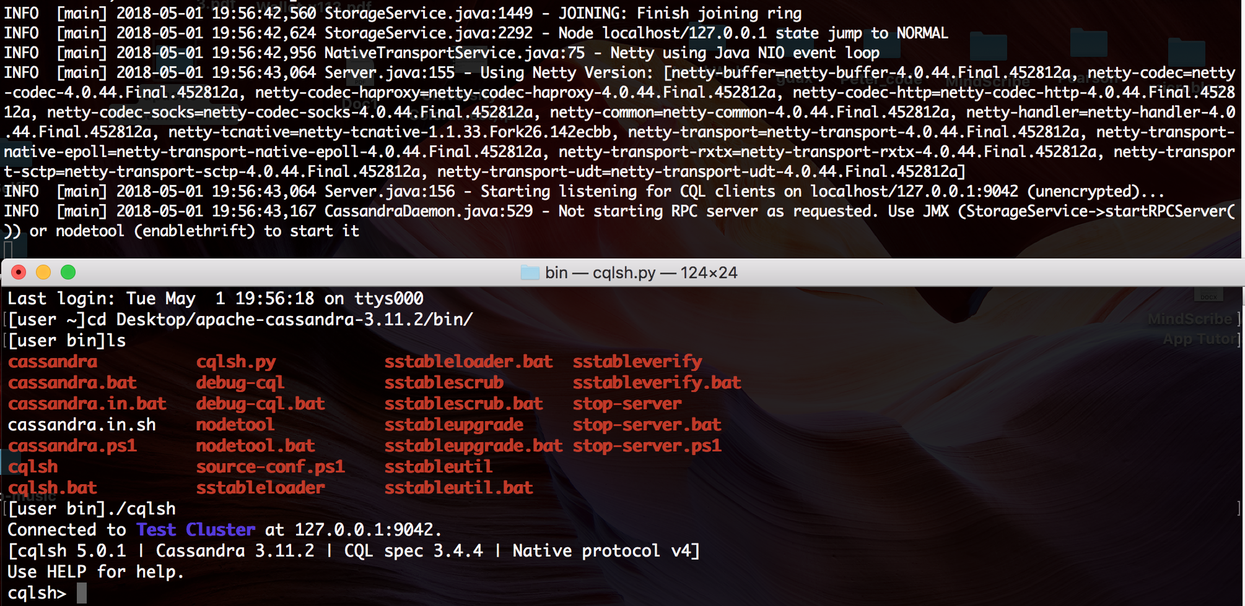

I run ./Cassandra -f to start the server, and I open up another terminal to run ./cqlsh , both under /bin

3) Create a keyspace

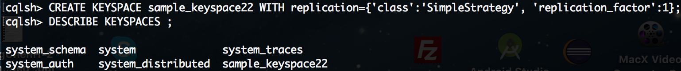

Comment: I create a keyspace, sample_keyspace22 with **replication** and **durable_writes**. And I verify with DESCRIBE command

Use keyspace

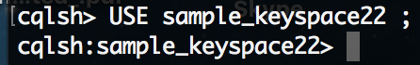

Comment: I switch into the keyspace by doing USE command

If you want to see all keyspaces in Cassandra

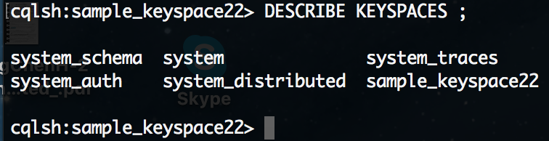

Comment: This command can let you see all keyspaces

4) To create a table

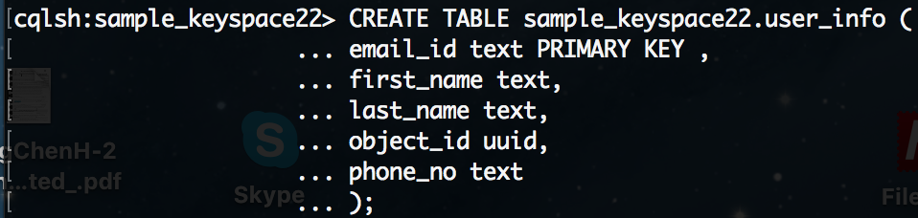

Comment: I create a table and define some columns with type

5) Insert a new row



Comment: You can insert values into a column, matching with each property.

If you want to see all column family in Cassandra,

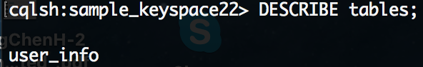

Comment: Before this command, you need to be inside of one keyspace, and then you can see all column inside of tables. In this case, it’s one

Describe a table;

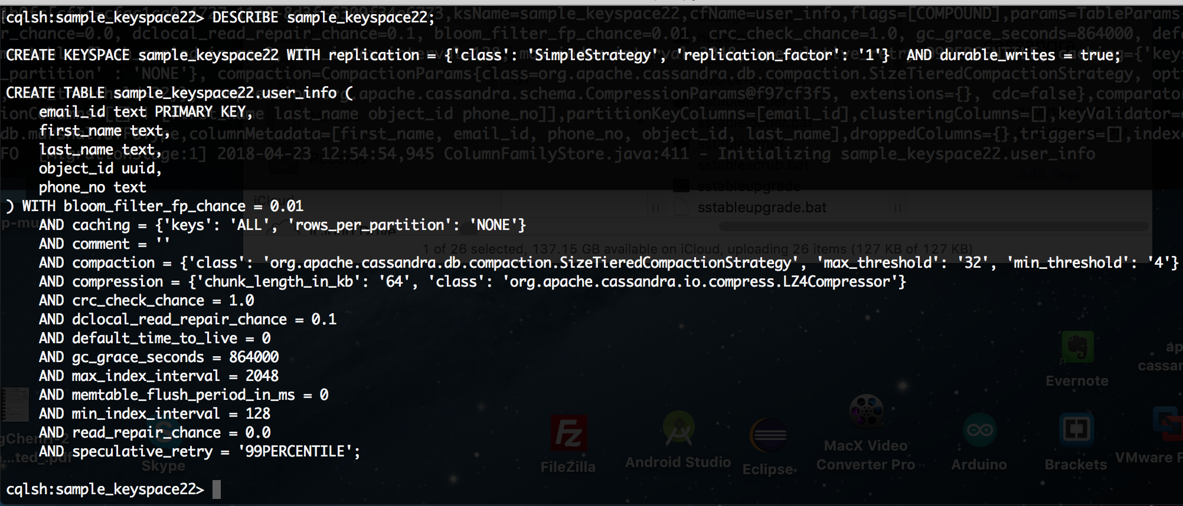

Comment: You can see a content of a table inside of a keyspace by doing this command

6) Create an Index



7) update a value

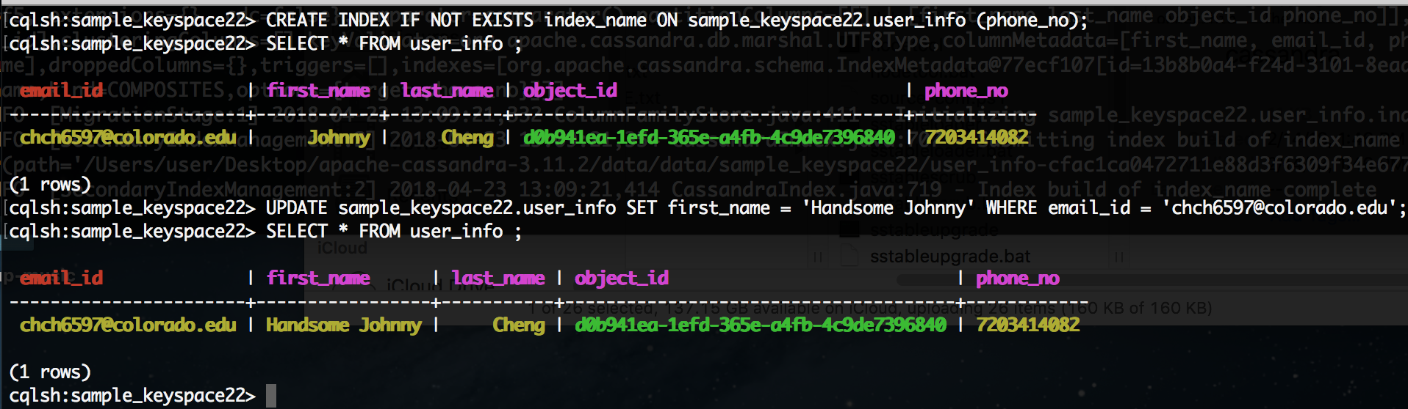

Comment: I update the first name with a new value

8) Add a column

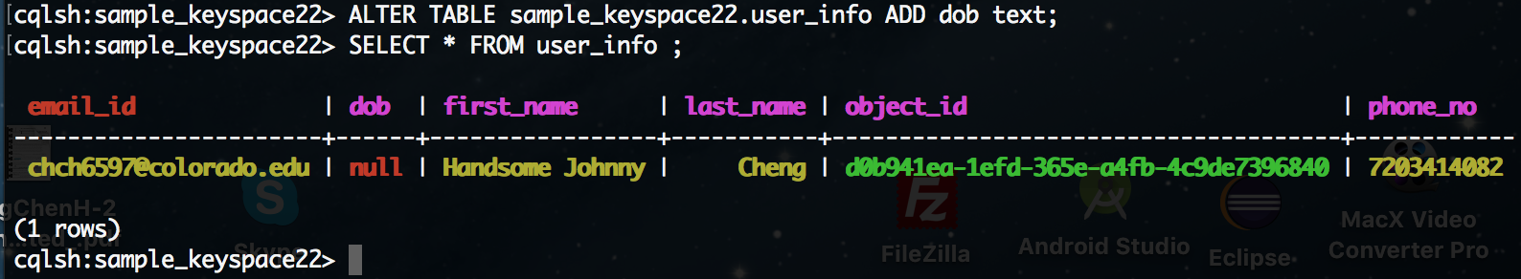

Comment: I add a new column called ‘dob’

9) Drop a column

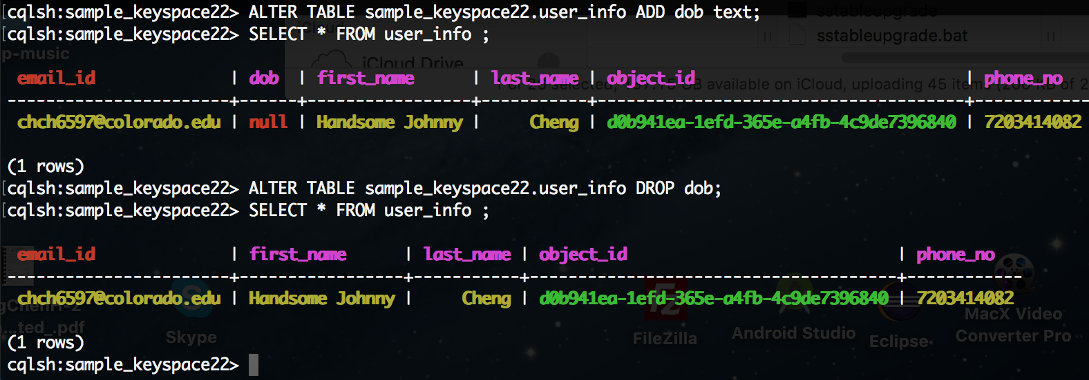

Comment: I drop the column ‘dob’

Rename a column: **Only primary key column can be renamed**

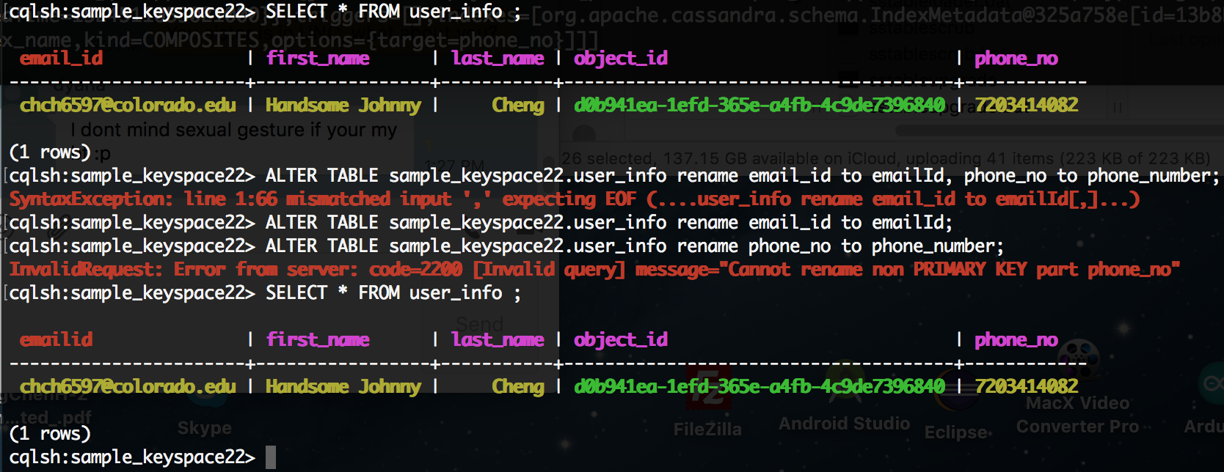

I rename the email_id into emailed. Get rid of ‘_’

10) Run a select query

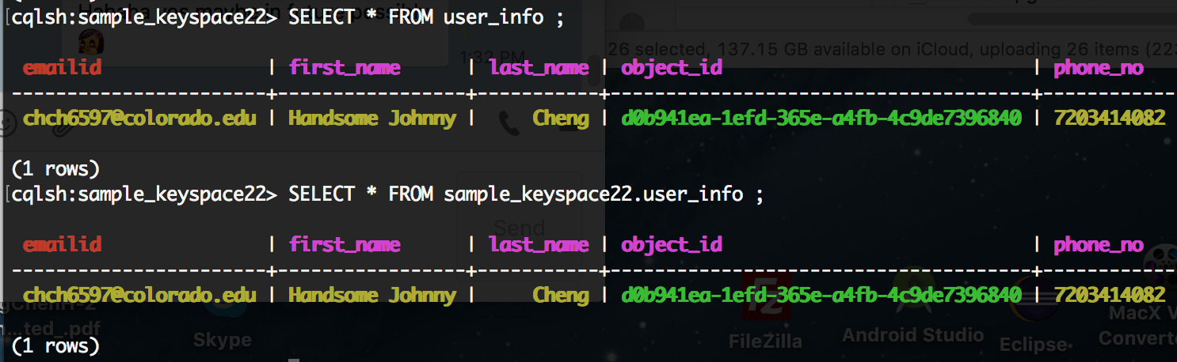

I try to see everything from user_info

Drop a table

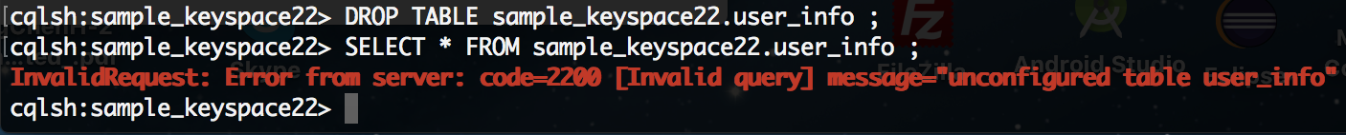

After I drop a table, the table is no longer existed

Drop a keyspace

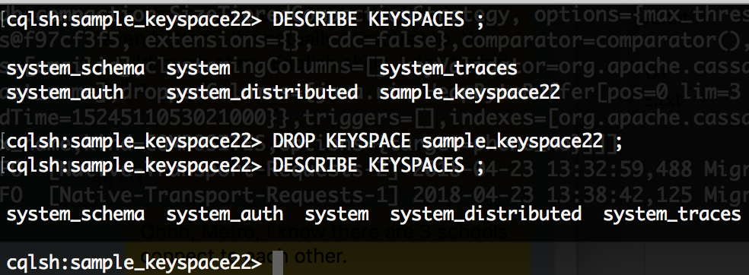

After dropping the keyspace, it’s no longer in keyspace. You can compare with the first picture